CURRICULUM VITAE
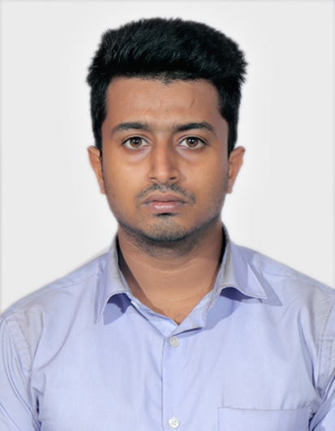

SHOVAN SAMANTA
ADDRESS- VILL +P.O. – GOPALPUR,
DURGAPUR, PASCHIM BARDHAMAN
WEST BENGAL
PIN CODE - 713212
CONTACT NO. - +917003604156
EMAIL ID – ssamanta.leather2020@gmail.com
DATE OF BIRTH - 27/09/1996
DATE OF BIRTH |  | : |  | 27th September 1996

OBJECTIVE: To Secure a Promising Position That Offers Both Challenge and Growth Where I Can Utilize My Skills and an Opportunity to Provide Meaningful Contribution to The Organization Working with.

ACADEMIC QUALIFICATION

TRADE INSTITUTION YEAR POINTS
B. Tech in  Leather Technology | Government College of Engineering &Leather Technology | Second Year (2017-2018) | 3rd semester | 6.21
B. Tech in  Leather Technology | Government College of Engineering &Leather Technology | Second Year (2017-2018) | 4th semester | 6.55
BOARD | MAKAUT | Third Year (2018-2019) | 5th semester | 6.8
BOARD | MAKAUT | Third Year (2018-2019) | 6th semester | 7.92
 |  | Fourth Year (2019-2020) | 7th semester 8.0  8th semester 9.76

Diploma in Leather Goods Technology | Central Footwear Training Centre | First Year (2014-2015) | 1st semester | 7.1
Diploma in Leather Goods Technology | Central Footwear Training Centre | First Year (2014-2015) | 2nd semester | 7.6
BOARD | WBSCTE | Second Year (2015-2016) | 3rd semester | 7.2
BOARD | WBSCTE | Second Year (2015-2016) | 4th semester | 7.8
 |  | Third Year (2016-2017) | 5th semester 7.5  6th semester 7.8
INTERNSHIP PROGRAM

STANDARD | BOARD | % OF MARKS | SCHOOL | YEAR OF  PASSING
10th | I.C.S.E. | 75 | ST. MICHAEL’S SCHOOL,  DURGAPUR | 2013
- One Month Internship at Balmer Lawrie (July, 2019 - August, 2019) – (Post Tanning operation)
- One Month Project at Lanxess Chemical House (Feb 2020 – March 2020) (Lesser Water consumption and water sustainability)

JOB EXPERIENCE

- 4 months’ job experience in Quantum System (Sept 2019- Dec2019)
Worked as Audit and Safety Management Trainee,
Faced 12 audits in 4 months with Team Leader.
- Worked for BSCI, ISO-14000, SA-8000, ETI, SEDEX, ISO-45001.
- Worked for 3 months in MediTourin.com as Business Development.
- Currently doing Freelancing in 3D model & Website Development.

OTHER ACHEIVEMENTS

- City Topper and district topper in Math’s Olympiad (2011-2012)
- Worked as Cultural Secretary in college life.
- Scored 22.67 in GATE XE 2020.

KEY SKILLS

- Basic Knowledge of coding on JAVA.
- User Friendly with Linux OS.
- Basic Knowledge of Accountancy.
- Basic Knowledge of Costing.
- Good with MS Office.
- Good with Excel Macro coding.
- Good with Photoshop and Lightroom.
- Good with Abode XD and Figma.
- Good with Adobe Illustrator, Adobe Dimension and Adobe Dreamweaver.
- Good knowledge with Blender.
- Good knowledge of PHP, CSS3, HTML5, SASS.
- Basic knowledge of JavaScript.
- Basic knowledge of React and Angular Framework.
- Good knowledge of Node.js & Express.js
- Basic knowledge on MongoDB and MySQL.
- Basic Knowledge on Python.

STRENGTH

- Posses good Leadership skill
- Having good Communication skills
- Having good fluency in English
- Being a quick learner
- Being Responsible and Self Motivated

LINGUISTIC PROFICIENCY

- English: Full professional linguistic
- Bengali: Native linguistic
- Hindi: Limited working linguistic

AREA OF INTEREST AND HOBBIES

- Read "As You Like It", "Julius Caesar", "Hamlet" by William Shakespeare and many others
- “The Prince”, “Friends not Master”, “Mein Kampf”, “Communist Manifesto” and many others
- History Lover
- Love Traveling, Exploring new places
- Semi Professional Photographer
- Blogger
- Fitness Freak

DECLARATION: THE ABOVE DETAILS ARE TRUE TO THE BEST OF MY KNOWLEDGE & BELIEF.

PLACE: KOLKATA SIGNATURE

